**Name: Ufaq Zahra**

**SEMESTER: 2nd**

**ROLL NO: SU92-MPMMW-F23-012**

**Assignment NO: 2**

**# Import necessary libraries**

import pandas as pd

from sklearn.model_selection import train_test_split

from sklearn.preprocessing import StandardScaler

from sklearn.linear_model import LogisticRegression

from sklearn.ensemble import BaggingClassifier, AdaBoostClassifier, GradientBoostingClassifier, StackingClassifier, VotingClassifier

from sklearn.ensemble import RandomForestClassifier

from sklearn.metrics import accuracy_score, precision_score, recall_score, f1_score, confusion_matrix, roc_curve, roc_auc_score

import matplotlib.pyplot as plt

**# Load the dataset**

df = pd.read_csv('/content/diabetes.csv')

**# Assume the last column is the target and the rest are features**

X = df.iloc[:, :-1]

y = df.iloc[:, -1]

**# Split the dataset into training and testing sets**

X_train, X_test, y_train, y_test = train_test_split(X, y, test_size=0.3, random_state=42)

**# Standardize the features**

scaler = StandardScaler()

X_train = scaler.fit_transform(X_train)

X_test = scaler.transform(X_test)

**# Initialize the base logistic regression model**

log_reg = LogisticRegression()

**# Fit the logistic regression model**

log_reg.fit(X_train, y_train)

**# Predictions**

y_pred = log_reg.predict(X_test)

y_pred_prob = log_reg.predict_proba(X_test)[:, 1]

**# Calculate metrics**

accuracy = accuracy_score(y_test, y_pred)

precision = precision_score(y_test, y_pred)

recall = recall_score(y_test, y_pred)

f1 = f1_score(y_test, y_pred)

conf_matrix = confusion_matrix(y_test, y_pred)

roc_auc = roc_auc_score(y_test, y_pred_prob)

fpr, tpr, _ = roc_curve(y_test, y_pred_prob)

**# Display metrics**

print(f"Accuracy: {accuracy:.4f}")

print(f"Precision: {precision:.4f}")

print(f"Recall: {recall:.4f}")

print(f"F1 Score: {f1:.4f}")

print("Confusion Matrix:")

print(conf_matrix)

print(f"ROC AUC: {roc_auc:.4f}")

**# Plot ROC Curve**

plt.figure()

plt.plot(fpr, tpr, color='blue', label=f'ROC Curve (area = {roc_auc:.4f})')

plt.plot([0, 1], [0, 1], color='red', linestyle='--')

plt.xlabel('False Positive Rate')

plt.ylabel('True Positive Rate')

plt.title('Receiver Operating Characteristic')

plt.legend()

plt.show()

**# Bagging with Logistic Regression**

bagging = BaggingClassifier(base_estimator=LogisticRegression(), n_estimators=50, random_state=42)

bagging.fit(X_train, y_train)

y_pred_bagging = bagging.predict(X_test)

print(f"Bagging Accuracy: {accuracy_score(y_test, y_pred_bagging):.4f}")

**# Boosting with Logistic Regression**

boosting = AdaBoostClassifier(base_estimator=LogisticRegression(), n_estimators=50, random_state=42)

boosting.fit(X_train, y_train)

y_pred_boosting = boosting.predict(X_test)

print(f"Boosting Accuracy: {accuracy_score(y_test, y_pred_boosting):.4f}")

**# Stacking with Logistic Regression**

estimators = [

('lr1', LogisticRegression()),

('lr2', LogisticRegression(penalty='l1', solver='liblinear')),

('lr3', LogisticRegression(penalty='l2'))

]

stacking = StackingClassifier(estimators=estimators, final_estimator=LogisticRegression())

stacking.fit(X_train, y_train)

y_pred_stacking = stacking.predict(X_test)

print(f"Stacking Accuracy: {accuracy_score(y_test, y_pred_stacking):.4f}")

**# Voting with Logistic Regression**

voting = VotingClassifier(estimators=estimators, voting='soft')

voting.fit(X_train, y_train)

y_pred_voting = voting.predict(X_test)

print(f"Voting Accuracy: {accuracy_score(y_test, y_pred_voting):.4f}")

**# Random Forest with Logistic Regression as base learner**

class CustomRandomForest:

def __init__(self, n_estimators=10):

self.n_estimators = n_estimators

self.models = [LogisticRegression() for _ in range(n_estimators)]

self.feature_subsets = []

def fit(self, X, y):

for i in range(self.n_estimators):

# Randomly select features for each model

subset = np.random.choice(X.shape[1], size=int(np.sqrt(X.shape[1])), replace=False)

self.feature_subsets.append(subset)

X_subset = X[:, subset]

self.models[i].fit(X_subset, y)

def predict(self, X):

preds = []

for i in range(self.n_estimators):

X_subset = X[:, self.feature_subsets[i]]

preds.append(self.models[i].predict(X_subset))

preds = np.array(preds)

# **Voting mechanism**

final_pred = np.mean(preds, axis=0) > 0.5

return final_pred.astype(int)

**# Use the custom Random Forest**

rf_lr = CustomRandomForest(n_estimators=10)

rf_lr.fit(X_train, y_train)

y_pred_rf_lr = rf_lr.predict(X_test)

print(f"Random Forest with Logistic Regression Accuracy: {accuracy_score(y_test, y_pred_rf_lr):.4f}")

**Output:**

**Accuracy: 0.7359**

**Precision: 0.6173**

**Recall: 0.6250**

**F1 Score: 0.6211**

**Confusion Matrix:**

**[[120 31]**

**[ 30 50]]**

**ROC AUC: 0.7978**

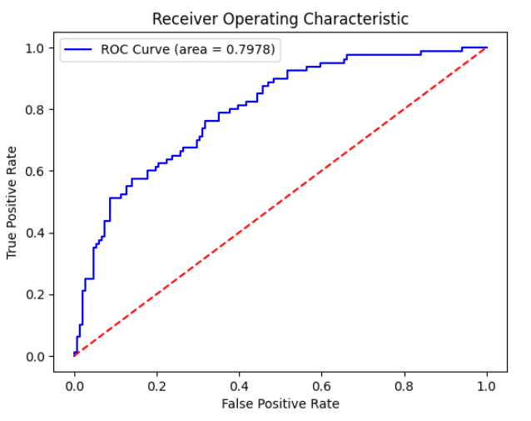

**Bagging Accuracy: 0.7273**

**Boosting Accuracy: 0.7013**

**Stacking Accuracy: 0.7316**

**Voting Accuracy: 0.7316**